

**Embry-Riddle Aeronautical University**

Prescott, Arizona

College of Engineering



Dylan Astrup, Detail Team Lead

Tesla Alford III

Titan Berson

Grant Carrabine

Hannah Spiller

Jacob Wolf

**Abstract**

The education of hydrogen production and storage is crucial to the potential future of the hydrogen economy. To carry out the goal of hydrogen education, ERH2 has built a hydrogen production and storage demonstrator consisting of an alkaline electrolysis system and material-based storage using lithium-doped graphitic carbon nitride. The cost of the system was $1419.53 and has the capability to run the supplied 1-Watt fuel cell. The electrolysis unit has viewable internals to increase the educational value of the project. The built system is a safe and educational method to introduce students and the public to hydrogen production and storage.

**Table of Contents**

List of Tables v

List of Figures vi

Nomenclature vii

Introduction and System Overview 1

Introduction 1

Problem Statement 1

Requirements 1

Purpose and Benefits 2

System Description 2

Concept of Operations 3

Electrolyzer 5

Material Storage 6

Valves 8

Extraction 9

Instrumentation 10

Requirements Verification 14

Budget 15

Conclusion 15

Acknowledgements 16

References 16

Appendix I

Appendix A: Team Organization Chart I

Appendix B: Itemized Budget II

# List of Tables

Table 1: ERH2 Requirements 1

Table 2: Material Capacity Test 7

Table 3: Production Rate Test 12

Table 4: Requirement Verification Table 14

[Table 5: Itemized Budget II](https://myerauedu.sharepoint.com/sites/H2Migos/Shared%20Documents/General/ERH2%20Final%20Paper.docx#_Toc133866031)

# List of Figures

Figure 1: System Configuration 2

Figure 2: Loading Capsule with Loading Rod 3

Figure 3: Complete System Configuration with Valves Open 3

Figure 4: Max Pressure with Second Valve Closed 4

Figure 5:Valves Close Heating Element On 4

Figure 6: Second Valve Open to Fuel Cell 5

Figure 7: Electrolyzer assembly 5

Figure 8: Material Storage Capsule 6

Figure 9: Material Storage Load Configuration 7

Figure 10: Valve Sub-Assembly 8

Figure 11: AN Flare Sub-Assembly 9

Figure 12: Heating Zone 10

Figure 13: Maximum Material Temperature 10

Figure 14: Pressure gauge 11

Figure 15: J-type thermocouple 12

Figure 16: Chemistry lab scale 13

Figure 17: K-type thermocouple 14

Figure 18: Subsystem Budgets 15

# Nomenclature

|  |  |
| --- | --- |
| Abbreviation | Definition |
| ERH2 | Embry-Riddle Hydrogen |
| DTL | Design Team Lead |
| ERAU | Embry-Riddle Aeronautical University |
| PTFE | PolyTetraFluoroEthylene |

# Introduction and System Overview

## Introduction

Currently, transportation companies like Toyota and Airbus are developing cars and airplanes that use hydrogen powered fuel cells to create energy. The problem with hydrogen as a fuel is that the current storage solutions of compressed storage and cryogenic storage are heavy, energy consuming, and potentially dangerous.

New research seeks to solve these problems using materials that store hydrogen. Labs and demonstrators that test and teach about these emerging technologies will let Embry-Riddle keep up with the rapid development of hydrogen as a clean energy alternative.

## Problem Statement

Embry-Riddle has tasked ERH2 with creating a demonstrator to produce and store hydrogen gas to run a 1-Watt fuel cell. Doing so requires the demonstrator to produce 0.002 grams of hydrogen gas every minute, store 0.01 grams of hydrogen, release 0.01 grams of hydrogen, and maintain safety.

## Requirements

The requirements for the system are derived from the need to produce hydrogen, store hydrogen, and run the fuel cell. The complete list of requirements is shown in the table below.

Table 1: ERH2 Requirements

|  |  |
| --- | --- |
| **Number** | **Requirement** |
| 1.1 | The system must produce hydrogen gas. |
| 1.1.1 | The system must produce enough hydrogen to get the fuel cell to steady state and then run for 10 minutes at 1 watt. |
| 1.1.2 | The system must be able to determine the rate of hydrogen gas produced. |
| 1.2 | The storage method must run the fuel cell for a minimum of 5 minutes. |
| 1.2.1 | The system must measure the amount of hydrogen stored. |
| 1.3 | The system must fit into the STEM 114 vent hood. |
| 1.4 | The system must interface with the Embry-Riddle fuel cell. |
| 1.4.1 | The system output must be a ¼” PTFE tube. |
| 1.5 | The fuel cell must not exceed the pressure of 0.29 psi. |
| 2.1 | The system must allow for safe production and extraction of hydrogen gas. |
| 2.2 | The system must follow Embry-Riddle Prescott Campus’ safety requirements. |
| 3.1 | The system must be able to be dissembled and reassembled to replace parts. |
| 3.2 | The machine must not allow the hydrogen and oxygen produced to mix. |
| 3.3 | The machine components must not be embrittled by hydrogen. |
| 3.4 | The amperage going into the system must be controlled and limited to 22.89 amps. |
| 4.1 | The storage material must be heated to 300°C and not exceed 350°C. |
| 4.2 | The storage material must be fully contained within the system. |
| 4.3 | The storage material must be at the end of the hydrogen flow. |
| 4.4 | The storage material must have a minimum hydrogen density of 2%wt. |
| 5.1 | The subsystem must transport hydrogen gas from the electrolyzer to the material storage, and from the material storage to the fuel cell. |
| 5.2 | The system must withstand temperatures up to 350°C. |
| 5.3 | The temperature at the valves must not exceed 50°C. |
| 6.1 | The instrumentation subsystem must be self-reliant |

## Purpose and Benefits

The purpose of Embry-Riddle Hydrogen is to generate and store hydrogen to power the Embry-Riddle 1-Watt fuel cell as a demonstrator to educate the population of Embry-Riddle Prescott about hydrogen and hydrogen material storage.

The design is affordable, innovative, and demonstrates the use of hydrogen material storage. The design consists of an electrolysis unit and material storage system. The electrolyzer is scalable and produces more than the required 0.02 grams to run the fuel cell for 10 minutes.

Material storage is an exciting new way to store the hydrogen that does not require high pressures and has greater weight capacity. Using material storage is a great demonstrator because it is visible and safe for interaction with the public.

# System Description

The ERH2 system consists of an alkaline electrolysis unit that produces hydrogen, and a material storage system that stores that hydrogen. To aid in production and storage, there are instruments to determine the production rates and valves to contain the hydrogen. The entire system can be seen in Figure 1 below.

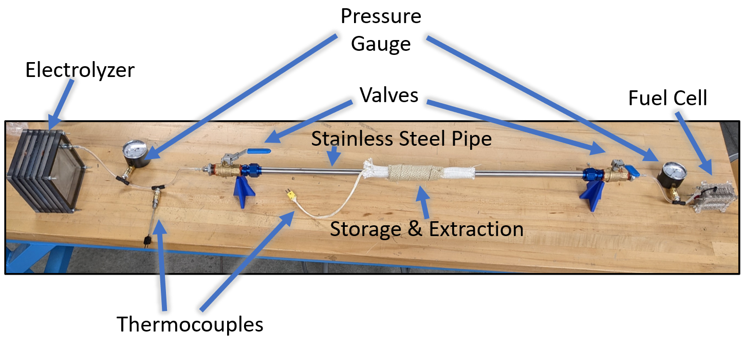

Figure 1: System Configuration

Hydrogen gas is generated in the alkaline electrolyzer using potassium hydroxide mixed with distilled water. The hydrogen then flows through the ¼ inch PTFE tubing and into the first set of instrumentation to verify temperature and pressure requirements of the hydrogen leaving the electrolyzer. Once the hydrogen passes the first set of instrumentation it then enters the stainless-steel pipe. The stainless-steel pipe houses a removable steel capsule containing the material storage powder. This material storage capsule has a 1-micron mesh on both sides, which allows hydrogen gas to flow yet prevents the powder from escaping.

The stainless-steel pipe also contains the heating mechanism that is used to release the hydrogen from the material storage. At the end of this pipe is the second set of instrumentation and the fuel cell. The fuel cell is a 1-Watt PEM (Proton Exchange Membrane) fuel cell that was provided by Embry-Riddle Prescott Campus’ ME energy department. When the hydrogen enters the fuel cell, it lights up a 1-Watt lightbulb.

## Concept of Operations

1. Record mass of the material storage capsule.
2. Load capsule into pipe, settling in the middle of heating zone, using loading rod.

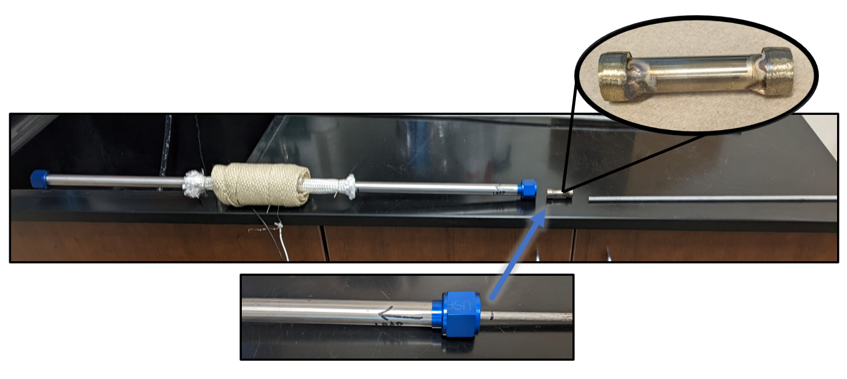

Figure 2: Loading Capsule with Loading Rod

1. Attach valve assembly onto stainless-steel pipe.

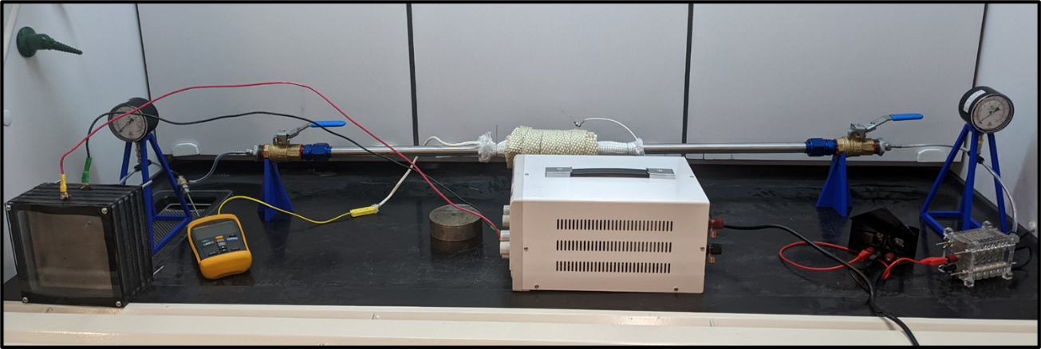

Figure 3: Complete System Configuration with Valves Open

1. Turn on electrolysis unit and flush ambient air out of pipe until light turns on (indicating complete hydrogen flush).
2. Close exit valve to begin loading material storage.
3. Run electrolysis until pressure gauge reads maximum pressure of 4 in-WC.

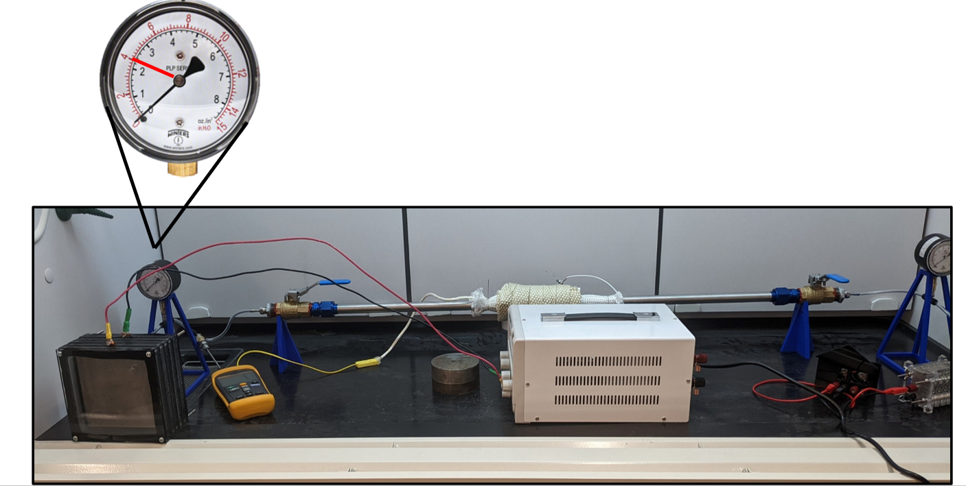

Figure 4: Max Pressure with Second Valve Closed

1. Turn off electrolysis, disconnect pipe from valve. Remove and weigh capsule.
2. Reinsert capsule into pipe using loading rod.
3. Turn on electrolysis and flush pipe until light turns on.
4. Turn off electrolysis, let fuel cell light turn off, close both valves, and turn on heating element.

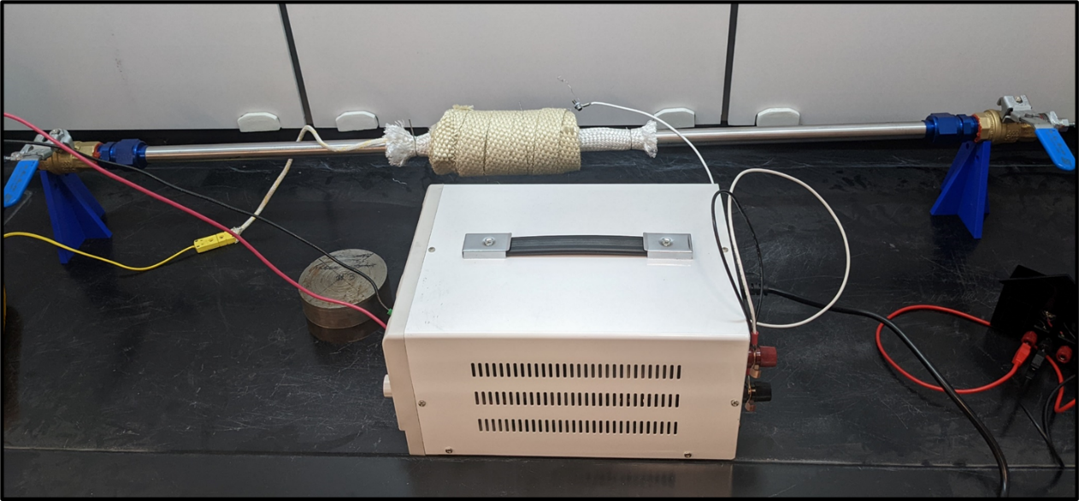

Figure 5:Valves Close Heating Element On

1. Once at 300°C, slowly open exit valve to power fuel cell.

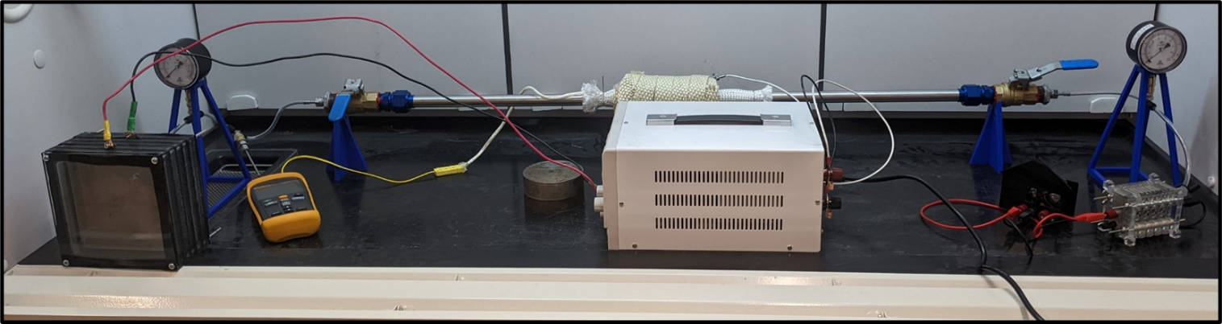

Figure 6: Second Valve Open to Fuel Cell

## Electrolyzer

This system produces hydrogen with an alkaline electrolyzer, which can control the output of hydrogen by controlling the input power. It consists of 7 polycarbonate layers, rubber gaskets, copper buses, and nickel meshes. It was filled with a solution of 32% potassium hydroxide dissolved in distilled water.

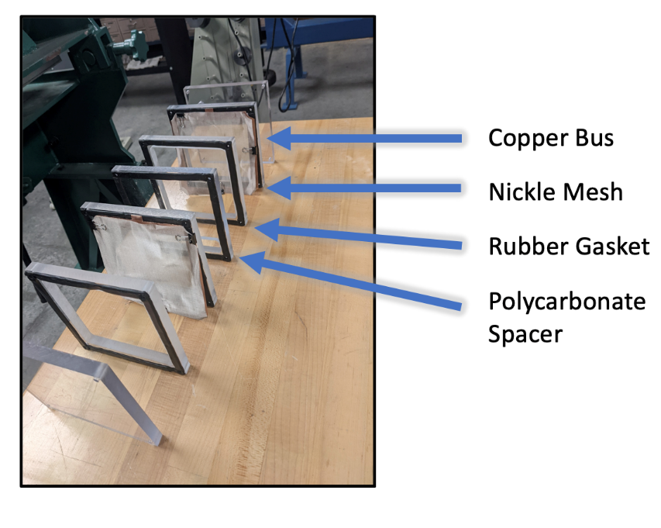

Figure 7: Electrolyzer assembly

As seen in figure 7 the electrolyzer utilized a sandwich design which made each component replaceable such as the end plates if different fittings are needed or when the nickel mesh needs to be replaced. This successfully completed requirement 3.1.

Also, utilizing the sandwich design the electrolyzer had a middle polycarbonate spacer that acts as a dividing wall separating the hydrogen and the oxygen. This successfully completed requirement 3.2. The housing material was made from polycarbonate to be hydrogen embrittlement resistant as well as nonconductive. This successfully completed requirement 3.3.

When running the electrolyzer we supplied a voltage of 4.6V and an amperage of 10.0A. This was not close to our limit of 22 amps since we were producing more than enough hydrogen to sufficiently run the test. This successfully completed requirement 3.4.

## Material Storage

The hydrogen was stored in lithium-doped graphitic carbon nitride. According to Murali et al., this material can store greater than 10 wt.% of hydrogen [1]. The material is made of carbon rings held by nitrogen covalent bonds. These bonds create larger holes that are filled when doped with lithium. The lithium attracts free hydrogen atoms and holds them in place. The material releases the hydrogen when heated to 300°C.

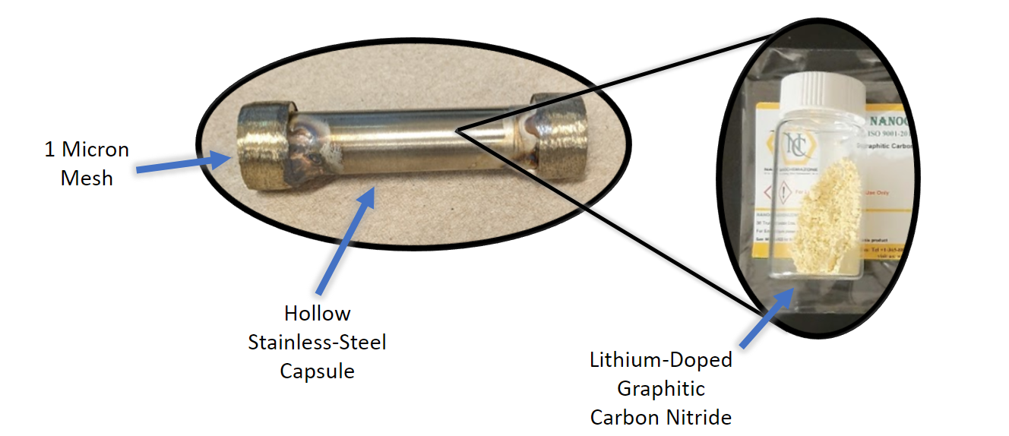

Figure 8: Material Storage Capsule

The material storage capsule used in testing contained about 0.5 grams of lithium-doped graphitic carbon nitride, which was inserted into a stainless-steel capsule with 1-micron mesh caps and was welded closed, as shown in Figure 8.

The meshes allow hydrogen to reach the material but prevents water vapor from entering and ruining the mass measurement and the absorption of the material. This fulfills requirement 4.2, that the storage material must be fully contained by the system.

When filling the storage material with hydrogen, the second valve is closed as seen in Figure 9.

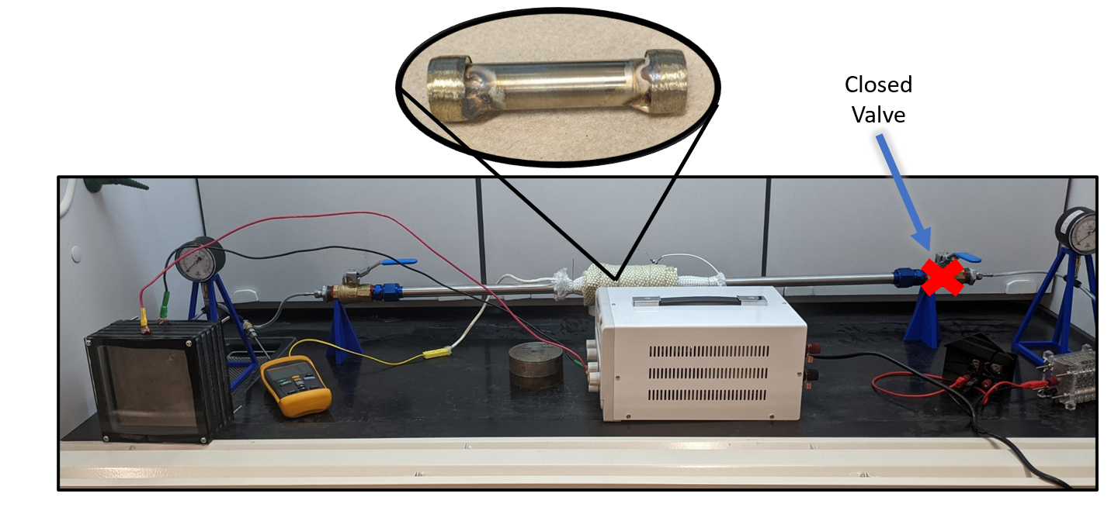

Figure 9: Material Storage Load Configuration

This configuration allows hydrogen to accumulate in the first half of the system where the capsule is. This fulfills requirement 4.3, that the material storage must be at the end of the hydrogen flow.

To measure the storage capacity of the material, the chemistry scales were used because they have an accuracy of ±0.0005 grams. Using this scale fulfills requirement 1.2.1 that the amount of hydrogen in the material must be measured.

Due to time restraints, a capacity test was only run once. The results of the test showed a mass increase of 0.02 grams from after boiling the capsule and filling the capsule with the last flush (as seen in Table 2). If most of this mass was due to hydrogen, this means the material has 3.87 wt.% hydrogen. Though this is a promising figure, we cannot definitively say that the mass increase was solely hydrogen because the test was only run once. There could have been dust, oil, or human error that interfered with the mass measurement, making it impossible to know if the mass increase was hydrogen.

Table 2: Material Capacity Test

|  |  |  |
| --- | --- | --- |
| **Mass (g)** | **Time & Day** | **Description** |
| 37.316 | 2:36pm 4/24 | First mass measurement. Before boiling away water & oil by heating it to 130C for a while |
| 37.294 | 3:00pm 4/24 | After boiling as described above |
| 37.306 | 4:41pm 4/24 | After filling capsule (0.012 g stored) |
| 37.314 | 5:40pm 4/24 | After trying to extract. Indicates unsuccessful extraction. We may have added more hydrogen during the flush. |
| 37.261 | 3:36pm 4/24 | After trying to extract again, capsule temp at about 192C |

The final mass measurement was taken after heating the capsule for about four hours. It is possible that over the extended time at 180°C, the capsule could have released some hydrogen (the 300°C metric was produced from research labs conducting short period-of-time tests). This hypothesis cannot be confirmed, as the fuel cell light did not turn on when the valve to the fuel cell was opened after the last failed extraction test.

Due to the long heating times, the capsule never reached the release temperature of 300°C. If there was more testing time or the design was improved, the capsule could be heated to release. Since the capsule never released the storage material never powered the fuel cell, requirement 1.2 to run the fuel cell was not fulfilled.

## Valves

The valve sub-assembly provides three main purposes to the system: it steps-up/steps-down the size of system from ¼ in PTFE to ¾ in pipe, controls the flow of hydrogen, and is removable from the pipe. There are two sub-assemblies within the system on each side of the stainless-steel pipe.

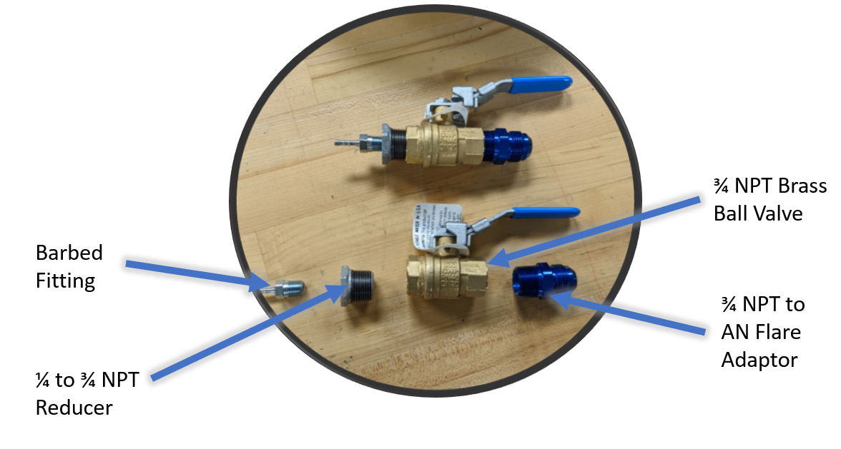

Figure 10: Valve Sub-Assembly

The valves interface with the ¼ in OD PTFE tubing using a ¼ in male barbed fitting to ¼ in NPT adaptor. The barbed adaptor is then threaded into a ¼ to ¾ in female to male NPT reducer. The reducer is then threaded into the ¾ in ball valve. Lastly, the other end of the ball valve is then threaded to a ¾ in NPT to AN flare adaptor. All NPT threaded components were sealed with RED RTV Silicone Gasket. The valve sub-assembly meets two of the main purposes; that being the step-up and step-down from ¼ in to ¾ in, and having it control the flow of hydrogen. In order to achieve the third purpose ERH2 decided to use AN flare adaptors on the stainless-steel pipe.

The AN flare adaptor sub-assembly is connected directly to the ¾ in NPT to AN flare adaptor. There is a total of two AN flare adaptor sub-assemblies to go along with the valve sub-assemblies.

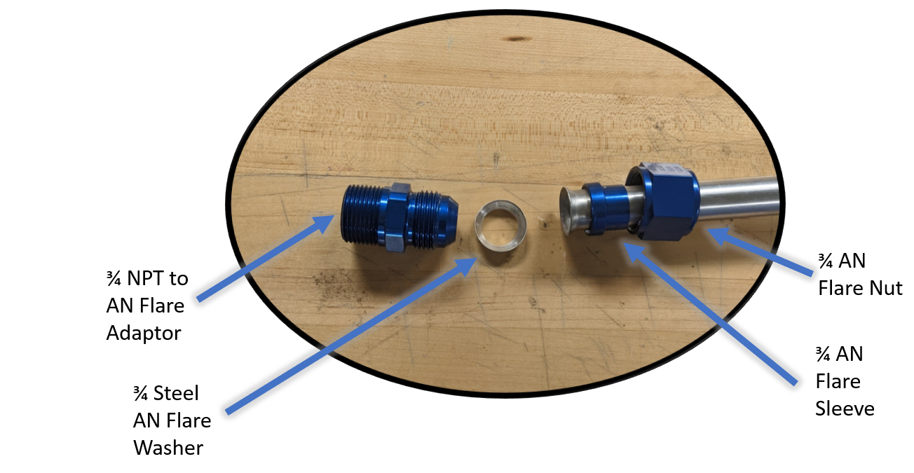

Figure 11: AN Flare Sub-Assembly

The AN flare sub-assembly contains one end of the ¾ in adaptor from the valve sub-assembly, a stainless-steel washer, a sleeve, and a nut.

Leak detection tests were done on all sub-systems using compressed air and soapy water. Each sub-system passed the test, but during testing the pressure from the instrumentation indicated leaks were still occurring. More advanced leak detection tests need to be done to improve the performance of the instrumentation. A potential leak test is to use helium instead of compressed air to mimic the size of hydrogen.

## Extraction

The extraction sub-assembly heats the material storage capsule within the stainless-steel pipe to any temperature between room temperature and 350°C. This system features 28-gauge nichrome wire as the heating element, a silica sleeve acting as electrical insulation between the heating element and the stainless-steel pipe, and silicate fiber strips acting as thermal insulation between the heating element and user (Figure 12).

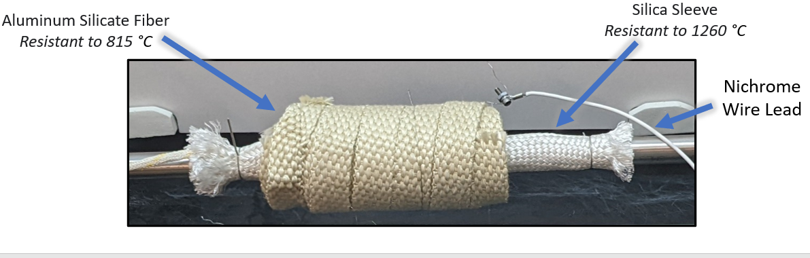

Figure 12: Heating Zone

The only portion of the system that reaches 350°C is the heating zone, and the materials used here resist these temperatures in fulfillment of requirement 5.2 that the system must withstand temperatures up to 350°C.

To achieve requirement 4.1 “The storage material must be heated to 300°C and not exceed 350°C,” thermal testing was performed to measure the power required to hit the minimum and maximum temperature points. From this data, the minimum and maximum power states to remain within the temperature range was established. The minimum power state is 16.77W to achieve 300°C and the maximum power state is 23.56W to achieve 350°C.

During material testing the maximum recorded temperature of the storage material was 200°C (shown in Figure 13), which does not meet requirement 4.1. The target temperature of 300°C was not met due to the issues described above in the Material Storage section.

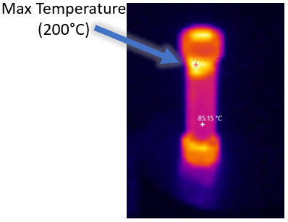

Figure 13: Maximum Material Temperature

## Instrumentation

The instrumentation used throughout the system was designed to display different measurements of different physical values throughout our system such as pressure and temperature. These values are also displayed to the audience of the demonstrator so that they can understand what is happening throughout the system.

To fulfill requirement 6.1, stating that the instrumentation must be self-reliant, all instrumentation selected was analog or battery powered. None of our instrumentation required expensive DAQ systems or computers. Our pressure gauges were analog, and we selected two thermocouples that easily interfaced with a battery powered thermocouple reader. This eliminated any need for large and expensive DAQ systems and met our 6.1 requirement.

The first instrument we used in our system was two 0-15 inwc pressure gauges, seen in the figure below. These pressure gauges were selected as they would be able to accurately indicate our very small pressure increase, which was expected to be around 4 inwc. These pressure gauges have a ±3-2-3% accuracy, making them very accurate and sufficient for our needs. They were integrated into the PTFE lines using a ¼ compression tee fitting and then a ¼ NPT female to female adapter.

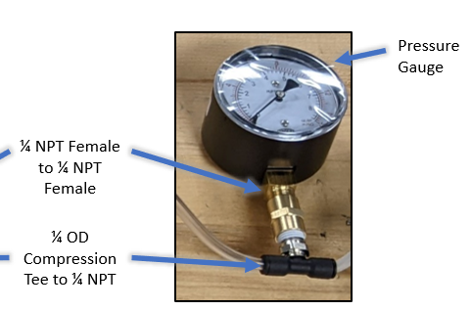

Figure 14: Pressure gauge

The first pressure gauge was located immediately after the electrolyzer. The main purpose of this pressure gauge was to record pressure increases as the electrolyzer produced hydrogen, so that using the Ideal Gas Law below, we could calculate the mass of hydrogen that the electrolyzer produces over time.

$$PV=mRT$$

Where:

$P$ = Absolute Pressure of gas (KPa)

$V$ = Volume of gas (L)

$m$ = Mass of gas (g)

$R$ = Ideal gas constant (KJ/Kg*K), Hydrogen = 4.124 KJ/Kg*K

$T$ = Absolute temperature of gas (K)

In addition to the pressure, we needed to measure the temperature of the hydrogen gas after electrolysis in order to get an accurate mass calculation. To do this, we used a J type thermocouple in a compression fitting to indicate the temperature of the gas at that point. This thermocouple has a ±2.2°C accuracy. This thermocouple interfaced with the PTFE piping identically to the pressure gauge discussed before, using a compression tee fitting and a female to female adapter.

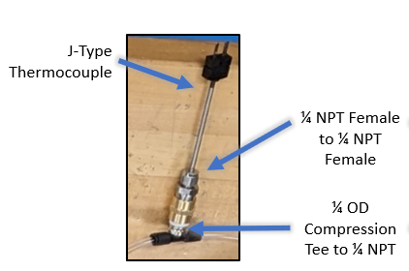

Figure 15: J-type thermocouple

To test the production rate of the electrolyzer, we turned on the electrolyzer to 5 amps, closed the first valve to limit the volume, and recorded the temperature and pressure over time. This can be seen in the table below.

Table 3: Production Rate Test

|  |  |  |  |  |
| --- | --- | --- | --- | --- |
| **Pressure (inWc)** | **Pressure (KPa)** | **Temperature (C)** | **Temperature (K)** | **m (g)** |
| 0 | 0 | 21.1 | 294.25 | **0** |
| 0 | 0 | 21.2 | 294.35 | **0** |
| 0.8 | 0.199054491 | 21.2 | 294.35 | **4.18147E-05** |
| 1.2 | 0.298581737 | 21.2 | 294.35 | **6.27221E-05** |
| 1.75 | 0.435431699 | 21.2 | 294.35 | **9.14698E-05** |
| 2.1 | 0.522518039 | 21.1 | 294.25 | **0.000109801** |
| 2.6 | 0.646927096 | 21.1 | 294.25 | **0.000135944** |
| 2.9 | 0.72157253 | 21 | 294.15 | **0.000151682** |
| 3.2 | 0.796217965 | 20.9 | 294.05 | **0.00016743** |
| 3.5 | 0.870863399 | 20.8 | 293.95 | **0.000183188** |
| 3.8 | 0.945508833 | 20.7 | 293.85 | **0.000198958** |

These mass calculations assume a constant volume of 0.255 L, and an R value of 4.124 KJ/Kg*K. If we take the total mass created over the 5 minutes of this test and find a production rate, we get a value of about 0.00003979 g/min. This is significantly less than the 0.002 g/min of hydrogen required to keep the fuel cell powered at a steady-state of 1 watt. But, we verified that our electrolyzer produces enough hydrogen to accomplish this steady-state output by running the fuel cell and light for over 30 minutes straight. This would indicate that our production rate, and therefore our mass measurement is inaccurate. This is likely due to the system having continual hydrogen leaks, as discussed in the valves section above.

Requirement 1.1.2 says that the system must determine the rate of hydrogen gas produced. We did not meet this requirement, as discussed above.

The second pressure gauge is located after the second valve before the fuel cell. The main purpose of this pressure gauge is to protect the fuel cell. The fuel cell has a pressure limit of 0.29 psi (~8 inwc), so this pressure gauge served to verify that we did not over pressure the fuel cell.

The next piece of instrumentation used was the chemistry lab scale. This was used to weight the material storage capsule to determine how much hydrogen was stored in the material. This scale had an accuracy of ±0.0005g. The material storage tests are discussed in the material storage section above.

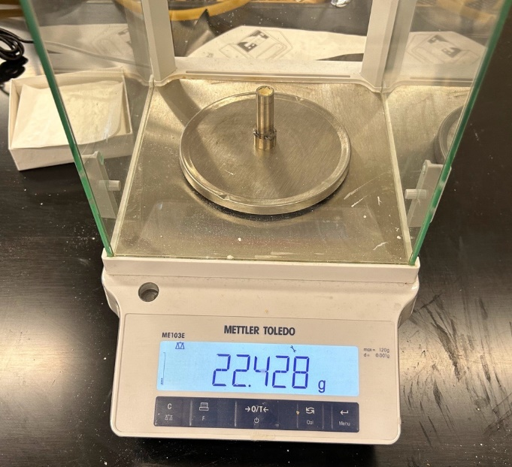

Figure 16: Chemistry lab scale

The final piece of instrumentation used in the system was a high temp insulated K-type thermocouple. This thermocouple had an accuracy of ±2.2°C. This thermocouple was integrated under the electrical insulation in the middle of the heating zone. This allows us to monitor the temperature of the capsule.

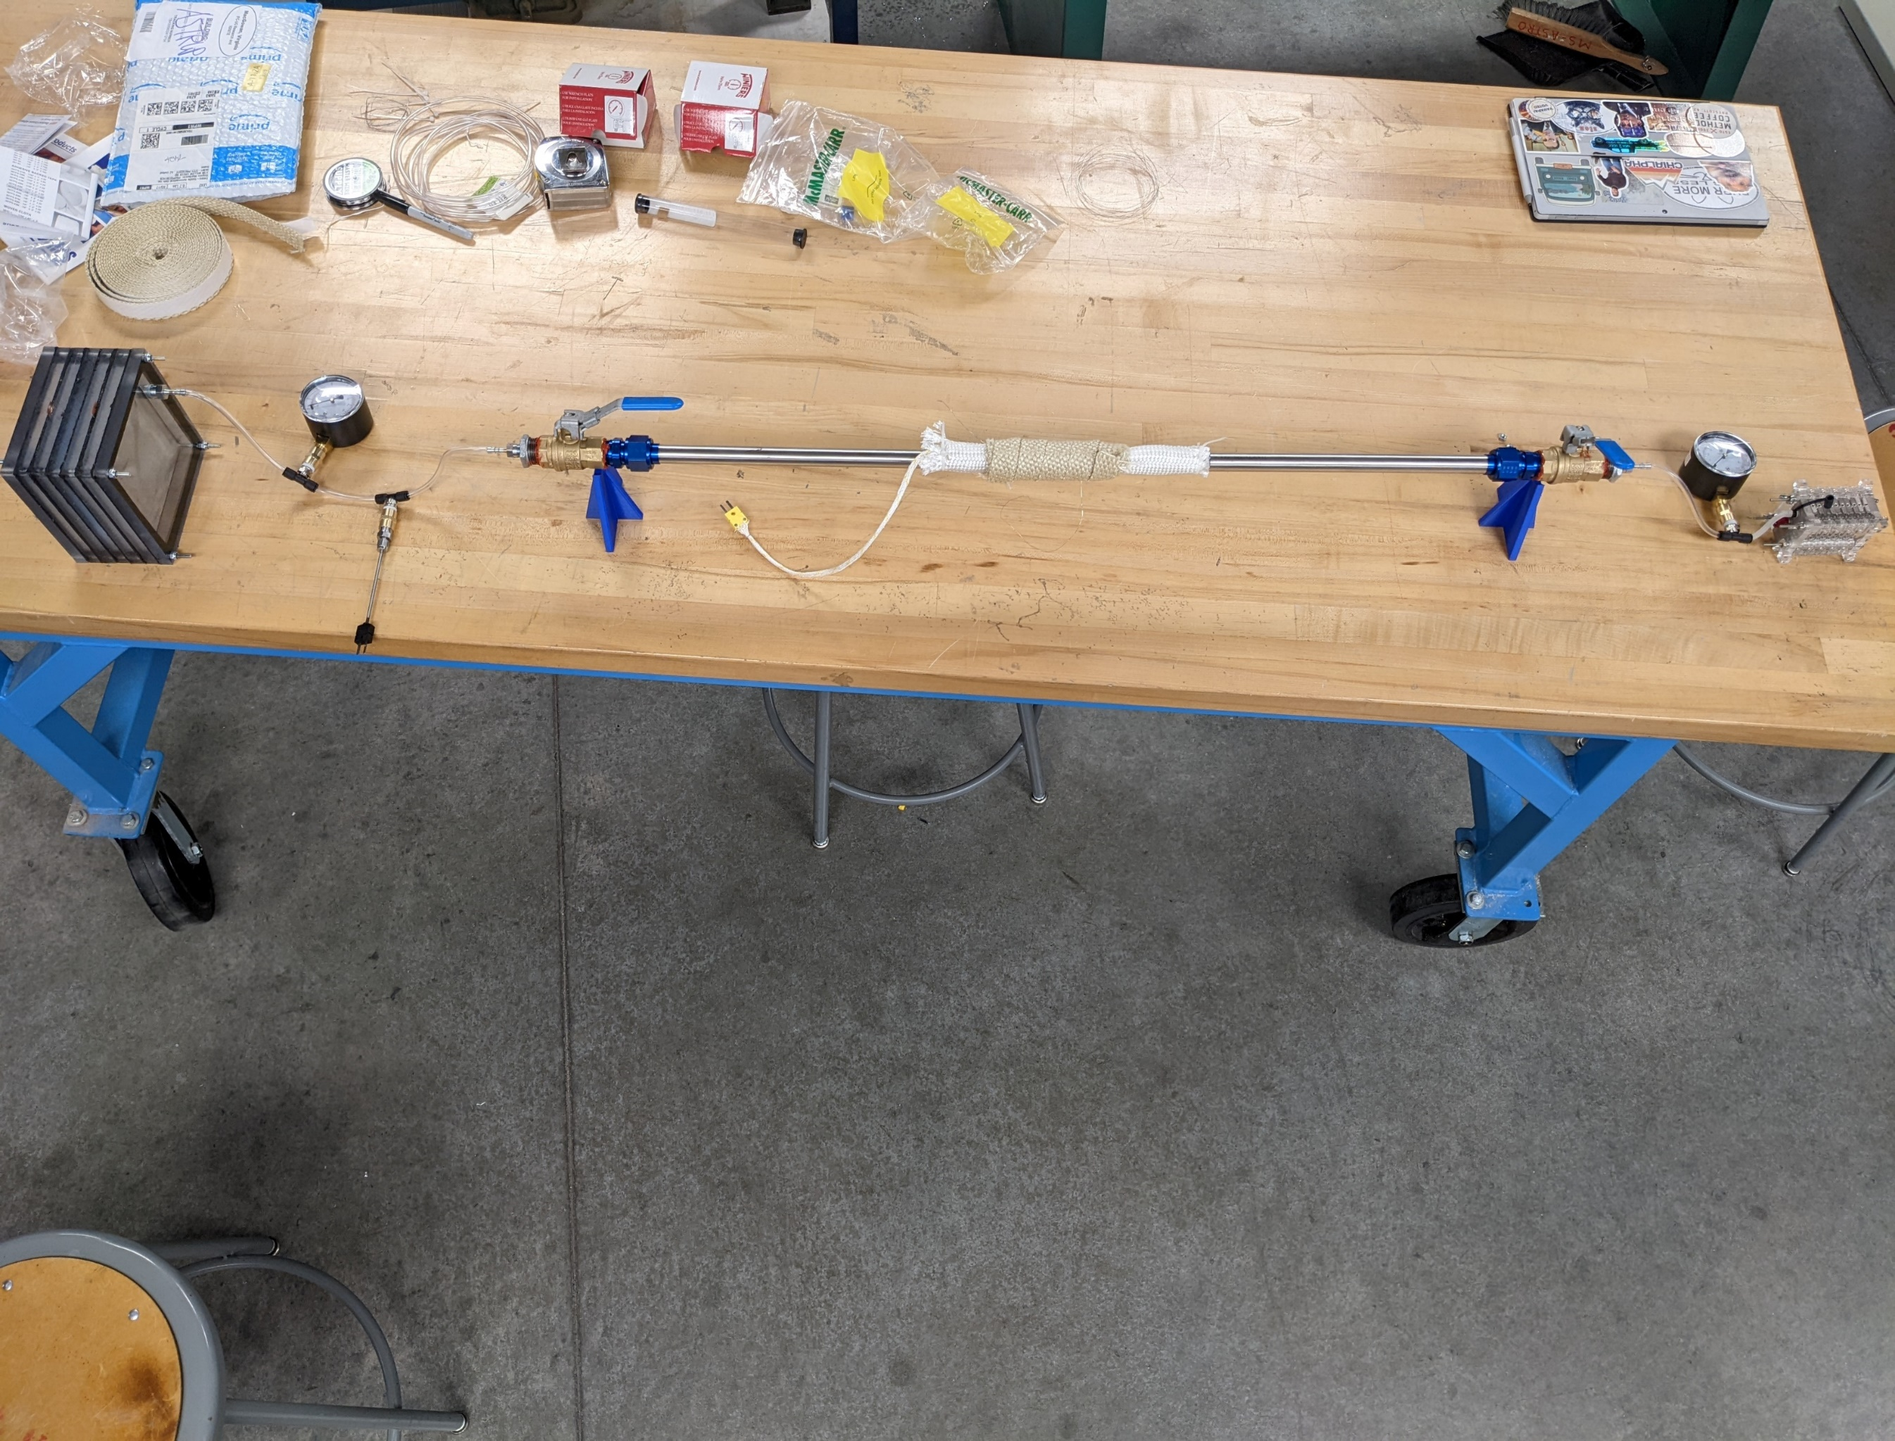

Figure 17: K-type thermocouple

## Requirements Verification

Table 4: Requirement Verification Table

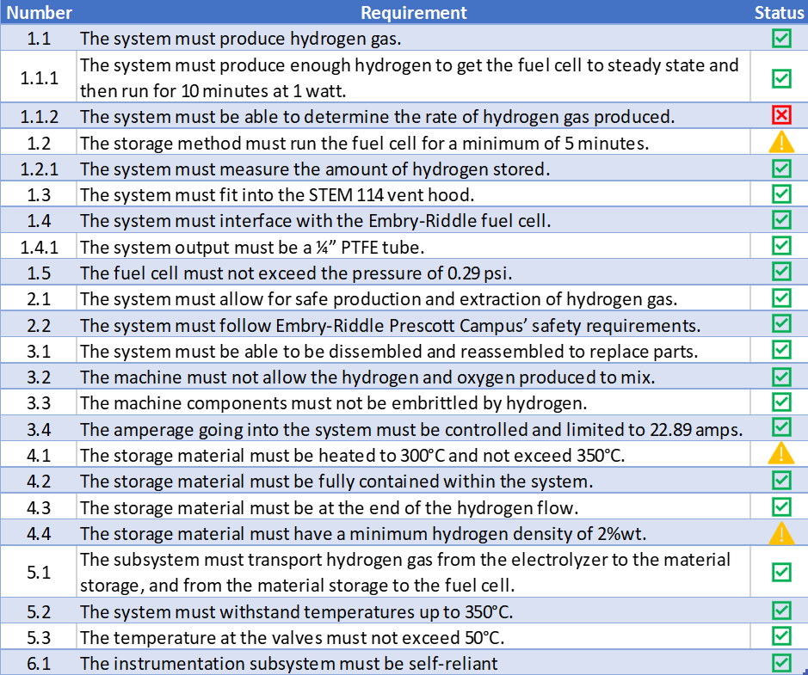

From table 4 above, most requirements have been met. The requirements marked incomplete do not have enough data to conclusively indicate if we have met that requirement or not. More testing must be done to get a conclusive result for these incomplete requirements. The requirement we did not pass, 1.1.2 that determines the hydrogen production rate, is discussed in the instrumentation section above.

# Budget

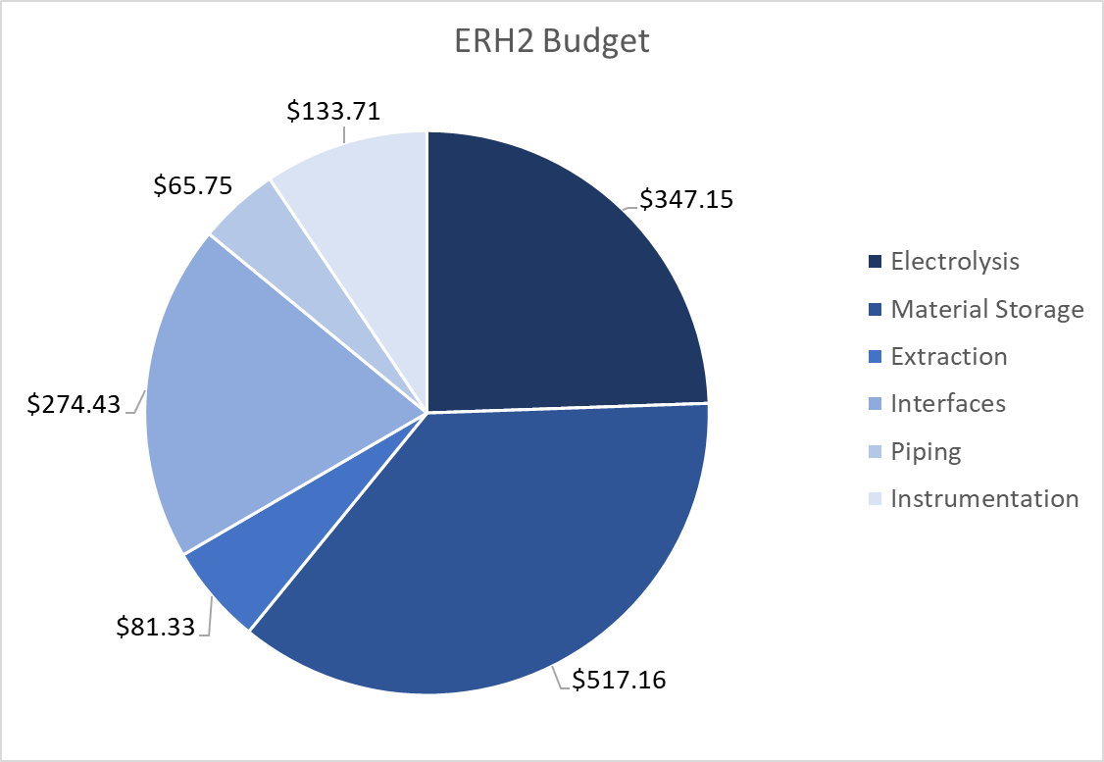

Figure 18: Subsystem Budgets

Above, the budget is broken down by subsystem. The largest expenses were the Material storage subsystem, mostly due to the $450/gram cost of the lithium doped graphitic carbon nitride, followed by the electrolysis subsystem which was high due to the purchase of our specialized power supply.

This came out to $1419.53, $119.53 over budget. This is mostly due to the unforeseen high cost of our material storage. An itemized budget can be found in Appendix B: Itemized Budget.

# Conclusion

The ERH2 demonstrator can successfully create hydrogen to run the ERAU fuel cell. Unfortunately, the material storage tests were inconclusive. This and other lessons learned during the testing process lead to the following recommendations:

Significantly shorten the length of the extraction system pipe. This will decrease the amount of time necessary to flush the system of excess air while still meeting the relevant temperature requirements.

Improve the heat transfer to the capsule to enable effective testing of the material storage.

Improve the hydrogen sealing, especially around instrumentation interfaces.

Conduct further testing on the material storage.

The ERH2 system has provided the groundwork for future material storage testing, and heeding the proceeding recommendations will provide effective research opportunities for ERAU Prescott.

# Acknowledgements

We would like to thank Dr. Ozsoy and Dr. Lanning for their help with picking materials. Dr. Heine, Dr. Adams, and Dr. Gerrick to help guide the team and give critical feedback to further the progress of the project. The AXFAB staff for their help throughout the design and manufacturing process. Dr. Eaton and Dr. DiPietro for their guidance in trade studies. Finally, Professor Schmidt for helping understand the chemistry of the material storage. Dr. Bryner and the prop lab team for helping with thermal imaging and instrumentation choice.

# References

[1] A. Murali, M. Sakar, S. Priya, R. J. Bensingh, and M. A. Kader, “Graphitic-Carbon Nitride for Hydrogen Storage,” in *Nanoscale Graphitic Carbon Nitride*, Elsevier, 2022, pp. 487–514. doi: 10.1016/B978-0-12-823034-3.00017-0.

# Appendix

## Diagram, timeline Description automatically generatedAppendix A: Team Organization Chart

## Appendix B: Itemized Budget

Table 5: Itemized Budget

Note: This table does not include shipping costs, the total listed in the Budget section above depicts the accurate total amount spent, $1419.53.